Composing for Harp

The basics.

Range:
Very similar range to piano.

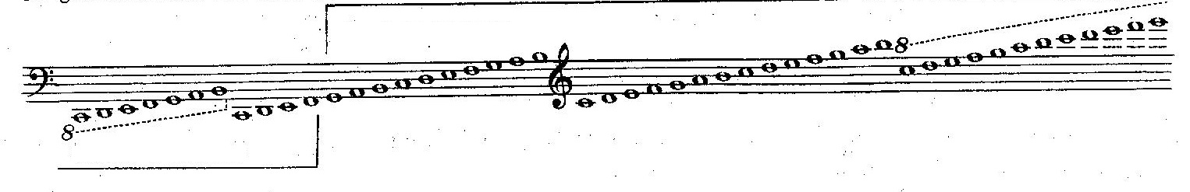
Method for Harp – Grossi

Left hand (LH) predominantly plays bass clef, right hand (RH) predominantly treble clef. These are interchangeable within reason, though we mostly prefer having our hands the normal way round. Be aware that while LH can cover the full range of the harp, RH cannot generally reach the bottom octave at all, and the F - C below the stave are generally not comfortable to reach for more than single notes.

Fingers:
99% of harpists DO NOT use the little fingers – please remember we are not like pianists!
Comfortable reach – 10th between thumb and 4th finger……. Less if both 2nd and 3rd fingers have notes in the chords. Also less if very uneven distribution of intervals between the fingers.

Pedals:
7 pedals – one for each note of the scale.
Split between the 2 feet – common pairs on opposite sides, ie B : E, C : F….
3 positions for each pedal – flat, natural and sharp, as indicated. Pedal moves affect that note in every octave, except…… lowest C and D and highest G have NO mechanism. Any changes to these have to be done manually. These notes can be, on occasions, tuned outside given range.

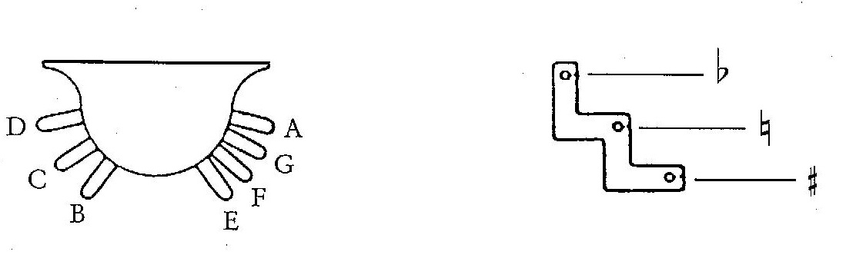
Harp Olympics – McDonald / Wood

Harpists CANNOT do double flats or double sharps unless we use the enharmonic equivalents. It is much kinder to write the enharmonic equivalents than to expect us to figure them out.

Harpists also cannot play chromatic scales with any speed.

Pedal diagrams are used to indicate the positions of the pedals at significant points in a piece.
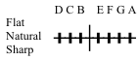

The vertical line shows the division between left and right foot. The central line indicates pedals in the natural (middle) position. Marks above indicate pedals in the flat position, marks below indicate the sharp position. Flats and sharps are sometimes notated with V’s rather than lines. Pedal diagrams can be placed between the staves, or above the stave. Individual pedal changes are notated by the name of the note, and its’ accidental, ie C#, Bb, and are usually between the staves.

Most harpists DO NOT read chord symbols – in fact we often mix them up with pedal markings. It is safest not to use chord symbols in harp compositions.

Harpists can easily move one pedal at a time with each foot. Changes where the pedals are both on the same side, or where multiple pedals are needed in a short space of time are more difficult. Please try to give the harpist time to get their pedals set when they need to move them.

Standard Techniques

Plucked effects:

Arpeggiated chords:
Chords are usually arpeggiated from bottom to top of the whole chord. Downward arpeggiation is notated with an arrowhead at the bottom.
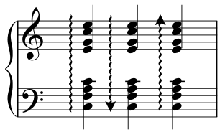
Upward arpeggiation does not require an arrowhead marking.
To play chords straight and unbroken, they are usually marked with a [ at the side.

Pres de la Table:
To play the strings very close to the soundboard, giving much more of an ‘edge’ to the sound.
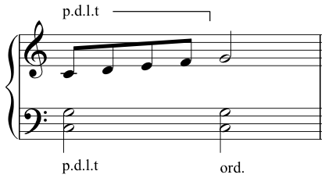

‘Ord’ can be used to indicate that the hands should return to the middle of the strings, or a guide line can be used to show where the effect should end.

Trills:
Notated as normal. Guidance for the required notes of the trill can be given. Single hand trills may be ‘played out’ as demisemiquavers or faster, depending on what the other hand is doing – it is almost impossible for the brain to have one have going at a fixed pace and the other hand going at a random pace! Where possible, trills are often split between the 2 hands for a smoother effect, or are played using a variety of finger patterns for the best result. Changes of direction at the end of a specific trill can also be notated.

Bisbigliando:
Harp equivalent of tremolo, played on the same chord, between the 2 hands, or 2 enharmonically equivalent chords. Usually rapid arpeggiation.
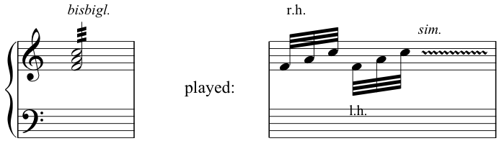

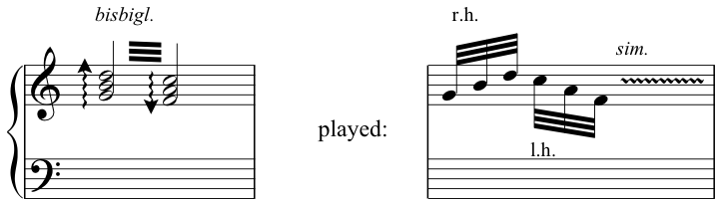

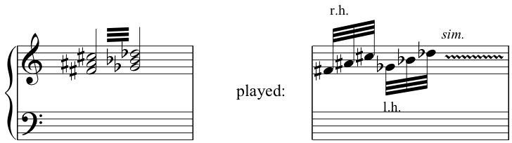

Bending notes:
Individual notes can be ‘bent’ or played with a vibrato effect. The note is played, then the string pressed repeatedly on the length between the tuning pin and the bridge pin.
It is most effective if the string is in its flat position.
Notated as
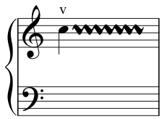

Use of nails:
The harp is normally played with the pads of the fingers, but at times nails are used to give the sound more of an edge.
Notated by a half moon shape over the relevant notes or section.
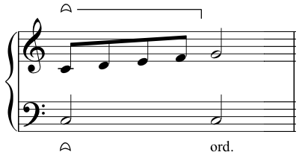
Glissandi can also be played with the nails.
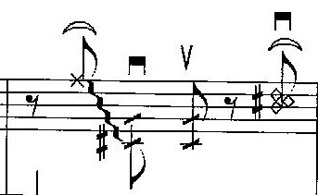
Baroque Flamenco – Deborah Henson-Conant

Xylophonic sounds:
One hand mutes up to 4 strings by pressing against the base of them, against the soundboard, while the other hand plays them.
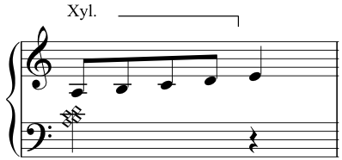
The notes to be muted are shown with diamond note heads.

Harmonics:
Standard harmonic notation consists of a circle above the note which is to be played as a harmonic. The harmonic will sound an octave higher. Please notate harmonics on the notes that you wish played, not as the sound that you wish to hear.
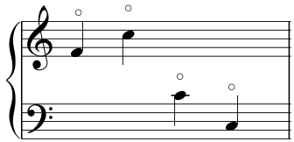

Harmonics can also be produced for other intervals, ie at the 12th – notate as standard marking, with 12th over or under the stave:

Harmonics can be included as the top notes of normal chords – the chords may well be arpeggiated to enable the harpist to reach all the required notes.
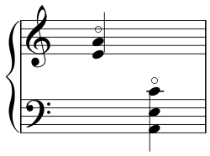
Chordal harmonics – doube or triple - can also be played by the LH within a range of approximately a 5th. (RH can only do single note harmonics due to hand position for playing harmonics). Each note to be played as a harmonic should be notated with a circle above the chord, so double harmonics would have 2 circles, triple harmonics, 3.

Pincé technique:

The string is played between the nails of the thumb and 2nd or 3rd fingers to give a very harsh tone.

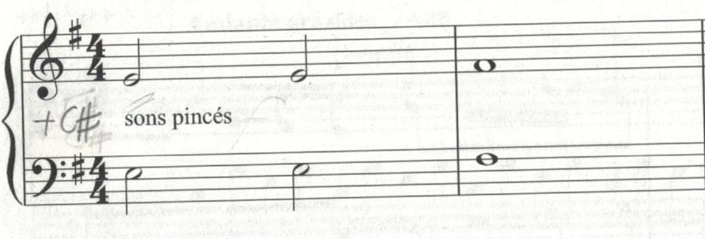

Damped effects:

Damping:
Notated by a quartered circle. Can be used to indicate damping the whole harp, if notated between the staves:
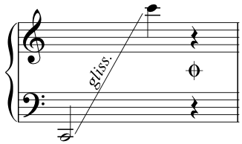

Damping single strings:
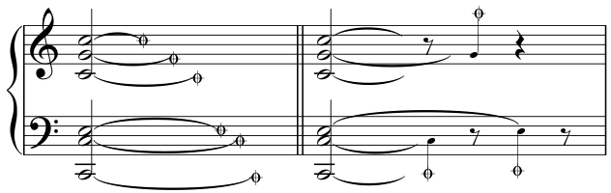

Or damping a specific section of the harp:
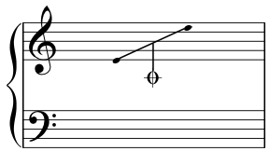

Staccato:
Usual notation of ‘.’ is used. Harpists can play staccato effects across single notes and chords, but the harp will still continue to resonate unless fully damped.

Etouffée:
Playing individual strings with the thumb, enables damping of previous notes, and gives more body to the tone of the notes being played. Often used when staccato notes are required.
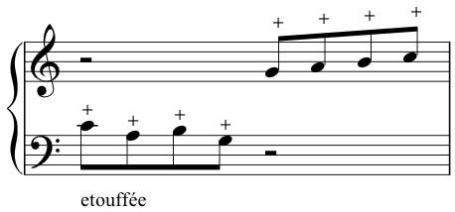
Often notated just with + above the notes.

Sliding effects:

Glissandi:
Slides, of various effects. Notated a number of ways.
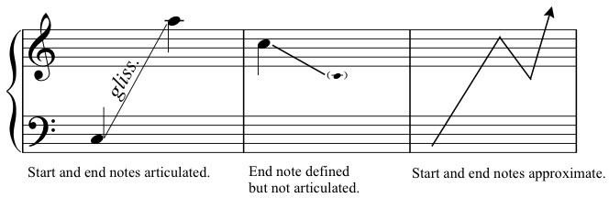
Approximate start and end notes can also be defined with an x as the head of the note.
Lines can also be wriggly. They do not have to be straight.

Glissandi requiring a specific note pattern can either be notated with a pedal diagram:
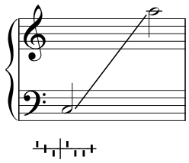

Or with the first octave of the glissando written in full:
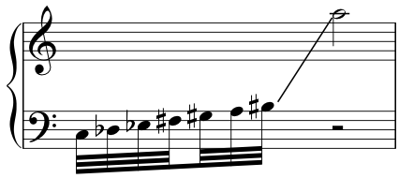

Single glissandi can be played with both hands at the same time, in the same or in opposite directions.

Chordal glissandi can also be played with a single hand, but tend to lack power, and it is hard to maintain specific intervals between the fingers:
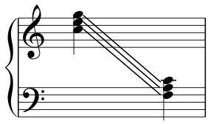

Percussion effects:

Tapping and slapping:
Both the strings, the soundboard and the body of the harp can be tapped and slapped.
Slapping the strings can be notated by square note heads
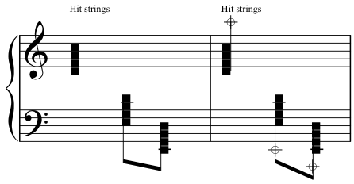
The hand can either be removed, to let the harp ring, or left on the strings to muffle the effect.
Percussion effects on the soundboard are usually notated between the staves

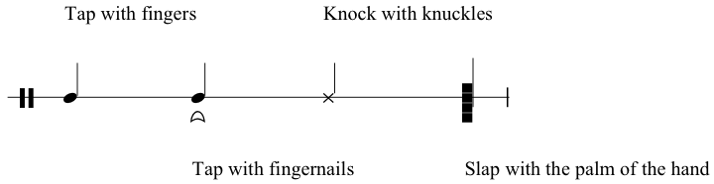

The direction of the note stems indicates which hand is used to make the effect.
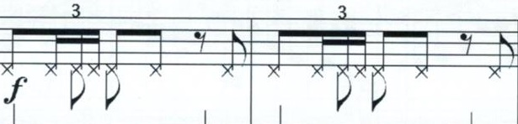
Baroque Flamenco – Deborah Henson-Conant

Upward stems indicating RH, downward indicating LH

Or notation can be made to shift the tapping between thumb (1) and fingers (2,3,4)
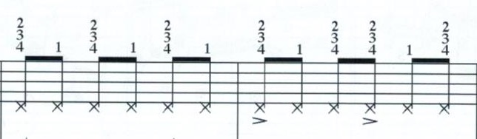
Baroque Flamenco – Deborah Henson-Conant

Tapping can also be indicated as follows
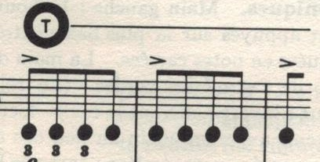
Modern Study of the Harp - Salzedo

Strumming:
A mixture of damped notes and finger strumming can be used for chordal effects
Direction of strum is indicated by symbols similar to those used for bowing markings on string instruments.
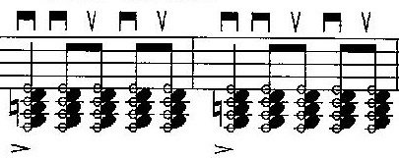
Baroque Flamenco – Deborah Henson-Conant

The clear notes are damped with the fingers of one hand, the black notes are strummed with the other hand.

Pedal effects:

Pedal slides:
Pedals can be used to create changes in harmony, by sliding them between the 3 positions. The lower strings will show more effect, and the slides are best done as soon as the strings are plucked.
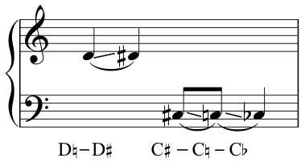

Pedals can also be used to create buzzes by holding the pedal mid-way between 2 notches, so that when played, the string collides with the firks on either side.

Pedal trills:
Created by playing the string, and then shifting the pedal rapidly back and forth between 2 positions, or by doing the same movement without playing the string first.

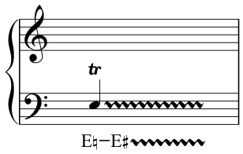

Accessories:

Many, many objects can be used as accessories to effect sounds, or to affect the sounds produced by a harp:
Hair clips, paper, tin foil, paper clips, tuning forks, felt, wooden rods, metal rods…..

Notation for these requires specific instruction for the nature of the effect, and time to prepare and remove it.
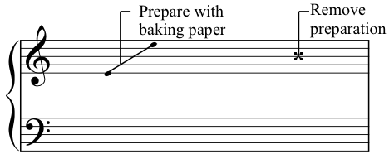
Edited notation:

Multi-stave notation:
Harp music can, on occasions be written across more than 2 staves, to make it easier to read:

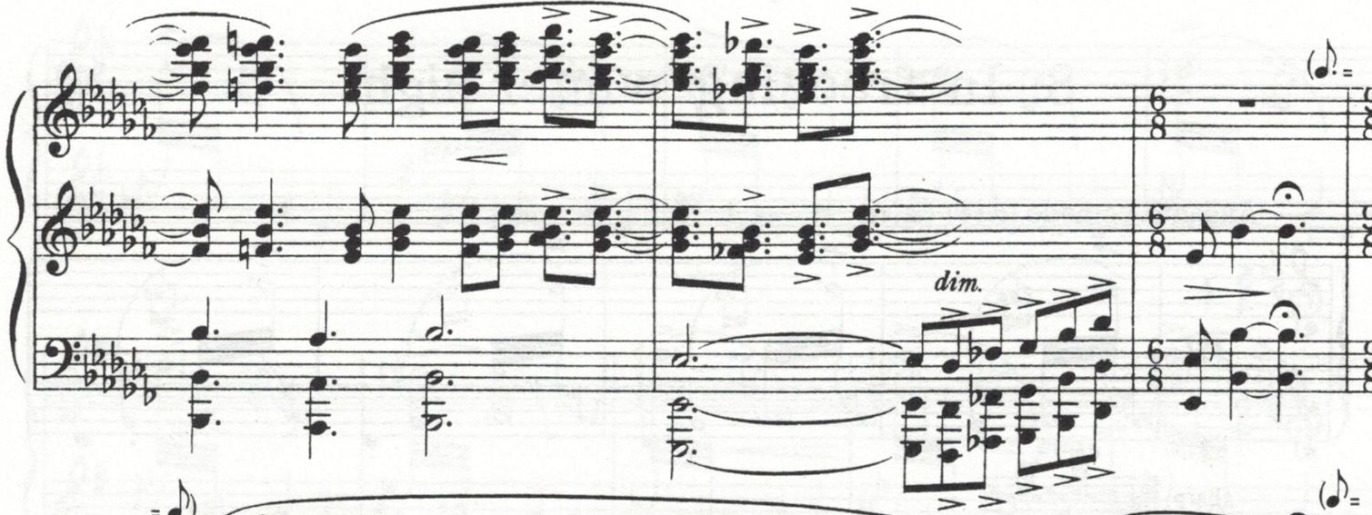
Interlude, from A Ceremony of Carols – Britten,

Edited key signatures:
In order to avoid the use of multiple accidentals within a piece, music for harp can be written with an edited key signature, as long as it is explained at the start.

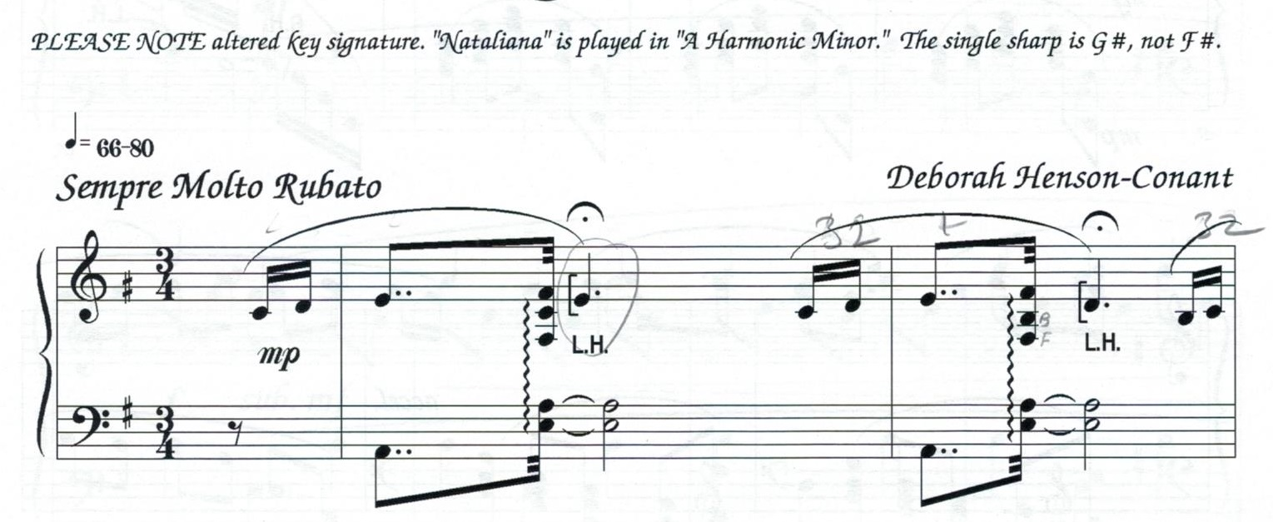
Nataliana – Deborah Henson-Conant

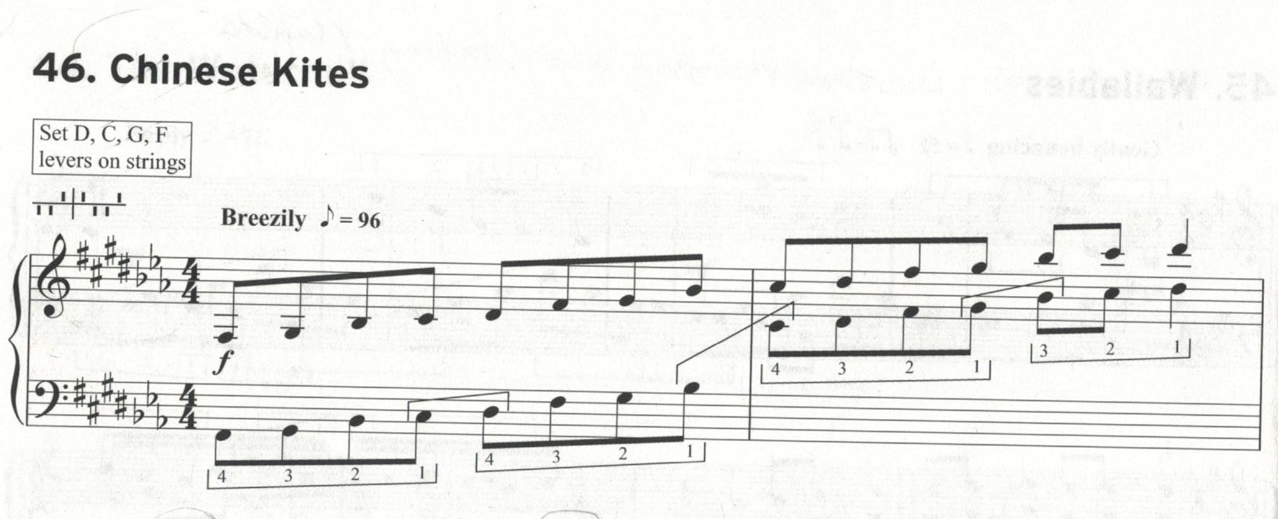
Technical Studies and Exercises for Trinity Music Exams – Trinity College London.

Single string alteration:
Individual notes can be de-tuned before the start of a piece, for specific effects.

For example, New Blues, by Deborah Henson-Conant has the G an octave and a half below middle C detuned by a semitone at the start, so that once the pedal is set for G# at the start of the piece that G remains as a G natural for the duration of the piece, preventing repeated pedalling in specific passages.

Salzedo effects:
Carlos Salzedo was an American harpist and harp composer at the start of the 20th century, who experimented a great deal with alternative effects that could be created on the harp. His effects come with their own lexicon, but are very interesting to explore.
Many of his effects can be found in his book: Modern Study of the Harp, which can be downloaded from the Petrucci Music Library.

http://ks.imslp.info/files/imglnks/usimg/0/08/IMSLP166593-PMLP296867-SALZEDO_L___tude_moderne_de_la_harpe.pdf

Remember if you want to create your own effects, please do. However, please give a written explanation of how you would like them played.

A general key to effects is always welcome at the start of a piece, even if the effects are among the more common ones.

Things to avoid…….

- LH / RH chords containing the same notes, unless intended as a trill or bisbigliando.
- Rapid pedal changes, both in terms of different notes, and changes from b - # - b…..
- Chords with too many notes. (Up to 8 works best, unless the chord is slow)
- Random sharps in a passage of flats, or vice versa – use the enharmonic instead.

Useful links
Unless otherwise identified, images used in this information come from the following website:
http://sites.siba.fi/en/web/harpnotation/harp
The site contains more details on composing for harp, and includes sample videos of most of the effects listed above. It also contains examples of a number of the less common effects.

Listening suggestions
For the more uncommon techniques:
Carlos Salzedo – Chanson dans las nuit
Pearl Chertok – Harpicide at Midnight (from ‘Around the Clock’ Suite)
Deborah Henson-Conant – Baroque Flamenco

